Dis-Paleo-Eur-England-Northfleet- Figurine-Venus-Flint nodule

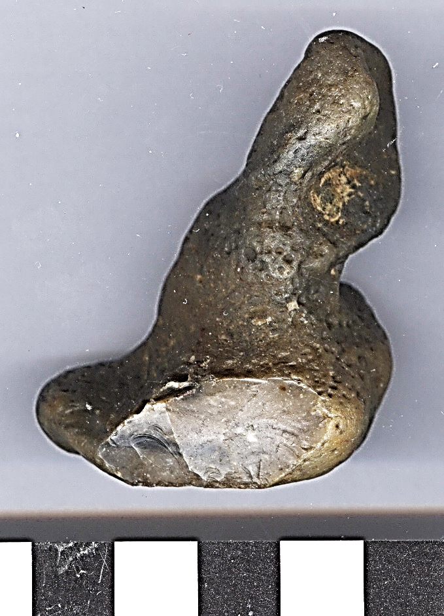 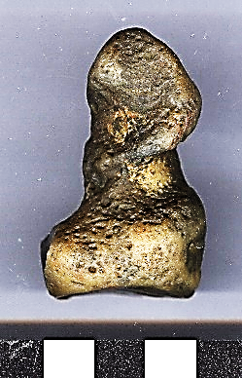 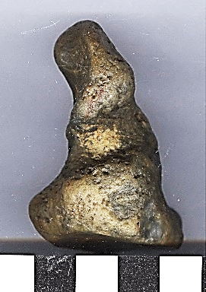

**Formal Label:**

**Display Description:**

**Accession Number:**

**LC Classification:**

**Date or Time Horizon:**

**Geographical Area:**

**Map, GPS coordinates:**

**Cultural Affiliation:**

**Media:**

**Dimensions:**

**Weight:**

**Condition:**

**Provenance:**

**Discussion:**

**References:**